Project Design Phase Solution Architecture
Data Science Project Documentation
Submitted By: Chukka Reddy Anusha, Roja | Date: 15 July 2026

Project Planning Phase
Project Planning Template (Product Backlog, Sprint Planning, Stories, Story points)

Team | Edralla Roja  Reddy Anusha
Project Name | Strategic product placement analysis: unveiling sales impact with tableau visualization

Product Backlog, Sprint Schedule, and Estimation (4 Marks)
Use the below template to create product backlog and sprint schedule

Sprint | Functional  Requirement  (Epic) |  | User Story  Number |  | User Story /  Task |  | Story  Points |  | Priority |  | Team  Members
Sprint-1 | Data Collection and Extraction of  Data |  | USN-1 |  | - Collect the dataset  - Understanding the  Data  - Connecting the dataset with  Tableau |  | 3 |  | High |  | Roja
Sprint-1 | Data Preparation |  | USN-2 |  | Prepare the Data for  Visualization |  | 5 |  | High |  | Roja
Sprint-2 | Data Visualization |  | USN-3 |  | No of Unique  Visualizations |  | 4 |  | Low |  | Roja
Sprint-1 | Dashboard | USN-4 |  | Responsive and  Design of  Dashboard |  | 3 |  | Medium |  | Roja
Sprint-1 | Story | USN-5 |  | No of Scenes of  Story |  | 5 |  | High |  | Anusha
Sprint-2 | Performance Testing | USN-6 |  | - Utilization of Filters  - No of  Calculation Fields  - No of  Visualizations/  Graphs |  | 8 |  | High |  | Anusha
Sprint-3 | Web integration | USN-7 |  | Dashboard and  Story embed with UI  With Flask |  | 5 |  | High |  | Anusha
Sprint-4 | Project  Demonstration &  Documentation | USN-8 |  | 1. Record an explanation Video for the project  end to  end solution  2 Project  Documentation-S tep  by step  project development procedure |  | 4 |  | High |  | Anusha

Project Tracker, Velocity & Burndown Chart: (4 Marks)

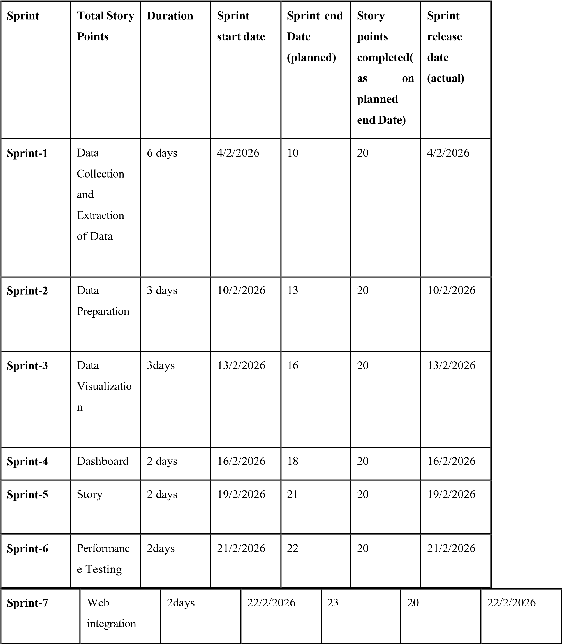
Sprint-8 | Project  Demonstrat ion &  Documenta  tion | 4 days | 23/2/2026 | 27 | 20 | 23/2/2026

Velocity:
Imagine we have a 10-day sprint duration, and the velocity of the team is 20 (points per sprint). Let’s calculate the team’s average velocity (AV) per iteration unit (story points per day)

